UNIVERSITY OF RWANDA

COLLEGE OF SCIENCE AND TECHNOLOGY SCHOOL OF ICT

COMPUTER AND SOFTWARE ENGINEERING DEPARTMENT NYARUGENGE CAMPUS
MODULE CODE/TITLE: WEB DESIGN

ASSISTABILITY WEBSITE –
BUILDING AN INCLUSIVE WORLD

225060001
Year of study: Year 1
Date:July 19, 2026

Project Technical Report- Web Technology TECHNICAL ASSESSMENT 2026

Table of Contents
List of Abbreviations 2
Chapter 1. Introduction 3
Chapter 2. System Analysis and Design 5
Chapter 3. Implementation 7
3.2.1. Home Page (index.html) 8
3.2.2. Locations Page (pages/location.html) 8
3.2.3. Visual Aids Page (pages/visual-aids.html) 9
3.2.4. How to Help Page (pages/support-guide.html) 9
3.2.5. Request Help Page (pages/request.html) 10
Chapter 4. Conclusion and Recommendation 11
Recommendations 11
To the Lecturer, on Technicalities 11
To the School, on Time Constraints 11
To the Partners (Targeted Organisations) 11
To the User, on Training 11
To the Beneficiaries, on the New Tool 11
Appendix. 12

Table of Figures
Figure 1 high-level Architecture 7
Figure 2 UI Design 7
Figure 3 Entity Relationship Diagram 8
Figure 4 landing page 9
Figure 5 Javascript function used here 9
Figure 6 location page 10
Figure 7 visual aids page 11
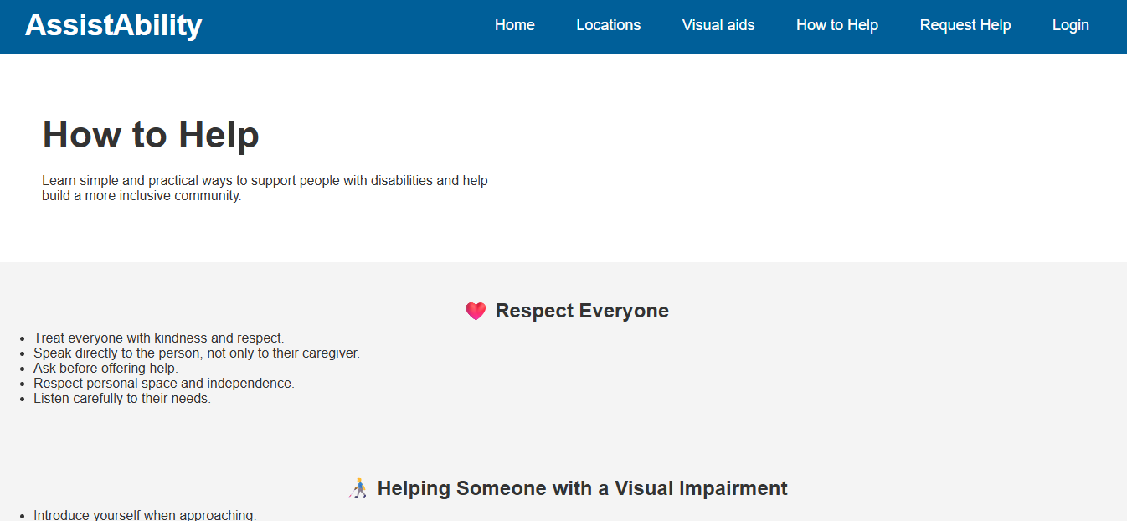Figure 8 how to help those with disability 12
Figure 9 request for help page 13
Figure 10 register as a volunteer or person with disability 13

List of Abbreviations

HTML: HyperText Markup Language
CSS: Cascading Style Sheets
JS: JavaScript
UI: User Interface
UX: User Experience
ERD: Entity Relationship Diagram
NGO: Non-Governmental Organization
API: Application Programming Interface
DOM: Document Object Model
NUDOR: National Union of Disability Organization of Rwanda

Chapter 1. Introduction
  - Historical background of the case study
Persons with disabilities represent a significant and often under-served part of Rwandan society. National and international estimates consistently place the proportion of people living with some form of disability at around 15% of the global population, and Rwanda is no exception. Over the past two decades, Rwanda has made deliberate policy commitments toward disability inclusion, reflected in the existence of dedicated organisations such as the National Union of Disability Organizations of Rwanda (NUDOR), the Rwanda National Union of the Deaf (RNUD), and the Rwanda Union of the Blind (RUB), among others. Despite these structures, the researcher observed — through informal community interaction and secondary sources — that awareness of how to locate these organisations, and how ordinary citizens should behave when supporting a person with a disability, remains fragmented and is rarely consolidated into a single, easily accessible digital resource.
AssistAbility was conceived against this background: a purely front-end web project developed for the Web Design module, whose purpose is to demonstrate core web-development competencies (semantic HTML structure, CSS layout and responsive design, and vanilla JavaScript DOM manipulation) while simultaneously producing something of genuine social value — a small, real directory of Rwandan disability-support organisations, an educational guide on respectful assistance, and an interactive sign-language learning tool.

  - Problem statement
People who wish to support persons with disabilities in Rwanda — whether as caregivers, volunteers, event organisers, or simply concerned members of the public — currently face three related gaps that this project addresses:
- Fragmented information: knowledge of which organisations exist, what they do, and where they are located is scattered across word-of-mouth, individual organisation websites, and government reports, with no single consolidated public directory.
- Low general awareness of etiquette: many well-meaning people do not know the basic, practical dos and don'ts of interacting with someone who has a visual, hearing, physical, or intellectual disability (for example, whether it is appropriate to push someone's wheelchair without asking).
- Limited accessible learning tools: introductory resources for learning sign language are not always presented in a simple, self-paced, step-by-step digital format suitable for a first-time learner.
AssistAbility responds to each of these gaps with a corresponding page: a Locations directory, a How to Help guide, and an interactive Sign Language lesson embedded on the home page, all wrapped around a central Request Help mechanism that lets a visitor ask for support directly.
  - Objectives of your project.
General objective: to design and implement a static, multi-page, responsive website that connects people with disabilities (and those who wish to support them) to relevant information, resources, and a simple request mechanism, using only HTML, CSS and vanilla JavaScript.
Specific objectives:
- To build a clear, semantic, multi-page site structure (home, locations, visual aids, how-to-help guide, and request-help form) sharing a single consistent navigation and footer.
- To implement an interactive, JavaScript-driven learning feature (the sign-language alphabet lesson) that manages UI state without any external framework.
- To compile and present a real, verified directory of Rwandan disability-support organisations, including an embedded interactive map.
- To design a clean, professional visual identity using a consistent CSS colour palette, card-based layouts, and flexbox for responsiveness.
- To design a request-for-assistance form capturing the key information a support organisation or volunteer would need to respond effectively.

  - Expected Outcomes
By the end of the project, the following outcomes are expected:
- A fully navigable five-page website (index.html plus four pages under pages/) with a shared, consistent header, navigation bar and footer across all pages.
- A working, self-contained sign-language alphabet learning widget requiring no page reload and no external dependency.
- A directory page listing at least six real Rwandan disability-support organisations with contact details and an embedded live map.
- A styled, responsive request form ready to be connected to a backend service in a future iteration of the project.
- A codebase organised into clearly separated concerns (css/, javascript/, pages/, assets/) that would allow another developer to extend the project without difficulty.

  - Project Rationale (Importance to the community)
AssistAbility is directly relevant to the community it targets. For persons with disabilities and their families, it lowers the barrier to discovering which organisations can help and how to reach them. For the general public — teachers, event organisers, transport operators, or simply neighbours — it offers a short, practical guide that can change day-to-day behaviour in ways that cost nothing but attention and respect. For student volunteers, it opens a concrete channel (the Request Help form) through which they might eventually be matched to real needs. Beyond its immediate audience, the project also demonstrates to the academic evaluator that solid front-end engineering practice (semantic HTML, maintainable CSS, and clean vanilla JavaScript) can be put in service of a socially meaningful cause rather than a purely abstract exercise.

Chapter 2. System Analysis and Design
- 2.1. System Analysis
2.1.1 Intended users of the project

- Persons with disabilities and their families — seeking information on nearby organisations, or wishing to submit a request for assistance.
- Caregivers and family members — who may complete the Request Help form on behalf of someone else (captured directly by the "Who needs help?" radio option on that form).
- General public / allies — visitors who simply want to learn respectful ways to interact with, and assist, people with disabilities (served by the How to Help page).
- Student or community volunteers — people interested in becoming a support volunteer, directed to the Request Help / "Become a Volunteer" call-to-action.
- Event organisers and institutions — who may consult the Accessibility Checklist on the How to Help page when preparing a venue or event.

2.1.2 Intended system partners
The project is designed to eventually operate in partnership with real Rwandan disability-support organisations already referenced in the Locations directory, namely NUDOR, the Rwanda National Union of the Deaf (RNUD), the Rwanda Union of the Blind (RUB), UPHLS, Tubiteho NGO, and the Rwanda Union of Little People (RULP). In its current front-end-only form, these organisations are represented as static directory entries; a natural extension of the project (outlined in Chapter 4) would be a formal data-sharing or referral partnership so that submissions through the Request Help form are actually routed to the correct partner organisation based on disability type and location.

- 2.2. System Design
    - High-Level Architecture

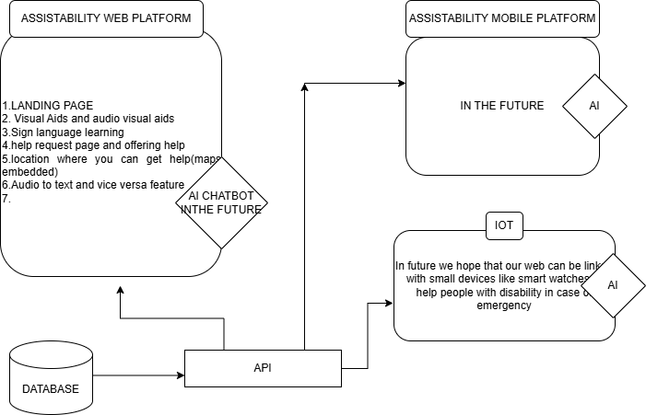
Figure 1 high-level Architecture

    - UI design (sketch of the UI module) and Flowcharts
Because AssistAbility is a multi-page site rather than a single-page application, its "flowchart" is best expressed as the navigation graph a user follows between pages, converging on the Request Help form as the primary action across the whole site.

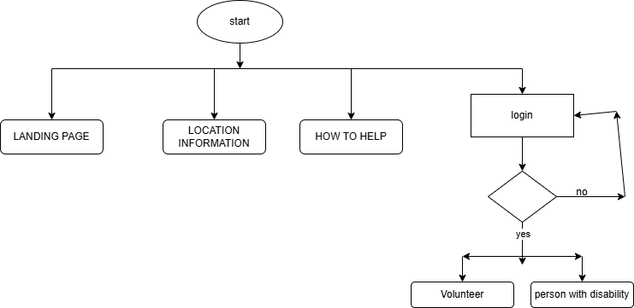
Figure 2 UI Design
    - Database design with ERD and relationships
The current implementation does not include a database — the Request Help form is a static HTML <form> with no backend handler, which was an appropriate and deliberate scope boundary for a front-end-focused module. However, to demonstrate design thinking for a natural next iteration of the project, the conceptual entity-relationship design below models how submitted requests could be persisted and matched to volunteers and partner organisations

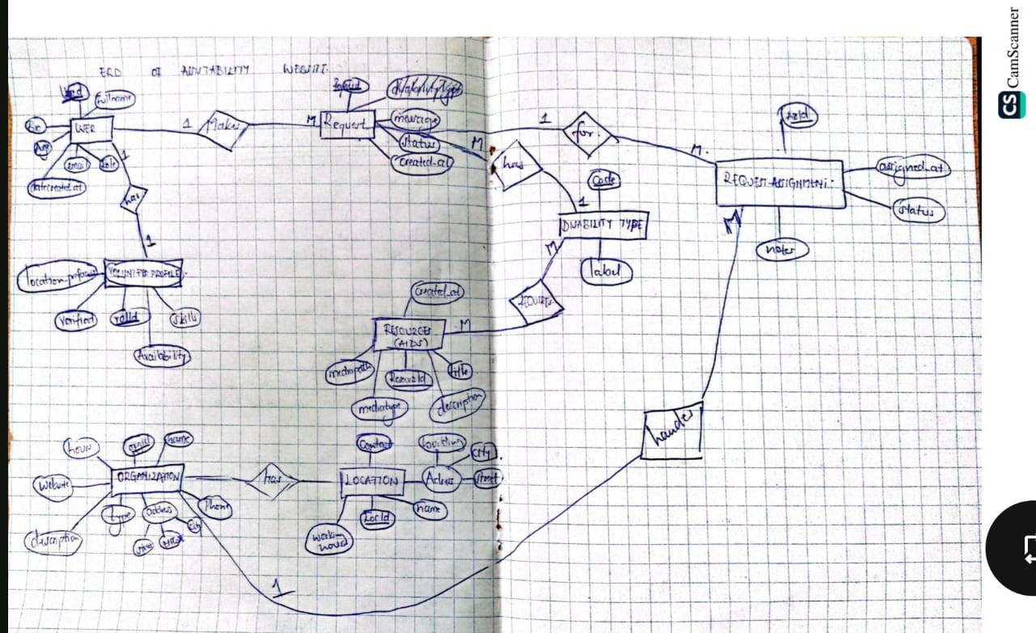
Figure 3 Entity Relationship Diagram

Chapter 3. Implementation
3.1. Introduction of the section
This chapter walks through the implemented pages of AssistAbility in the order a typical visitor would encounter them, discussing for each page the specific HTML structure, CSS layout technique, and (where applicable) JavaScript logic used, together with the reasoning behind key implementation decisions. Screenshot placeholders are marked below; replace each placeholder with an actual screenshot captured from the running site (opening index.html or the relevant page in a browser) before final submission.

3.2.1. Home Page (index.html)
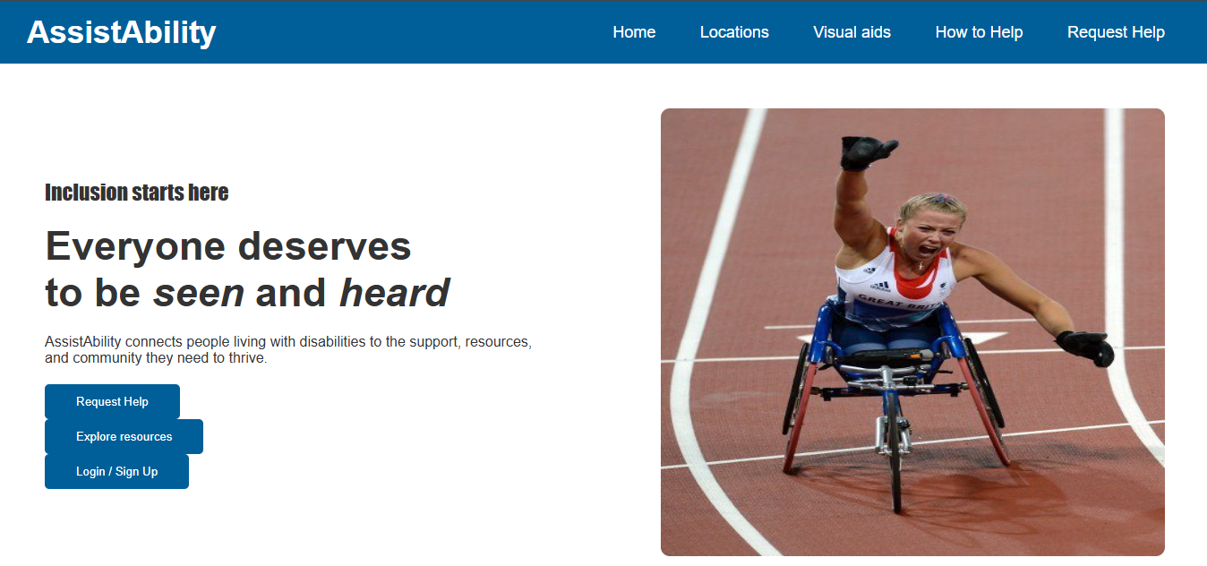
Figure 4 landing page
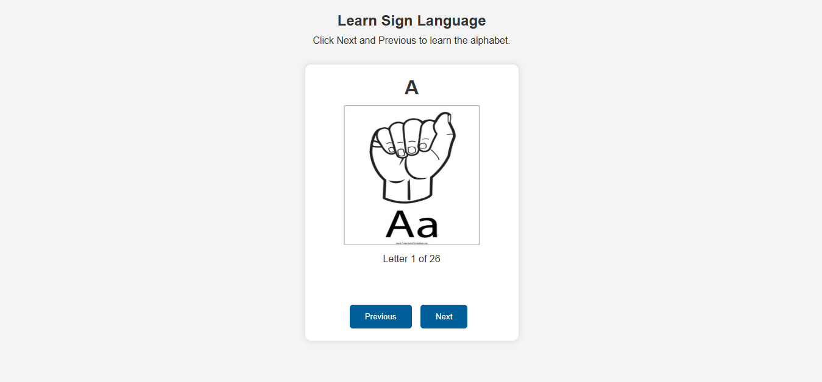
Figure 5 Javascript function used here
The home page is the entry point of AssistAbility. It opens with a hero section built with a flex-based two-column layout: the left column carries the headline "Everyone deserves to be seen and heard" together with a short mission statement and two call-to-action buttons ("Request Help" and "Explore resources"), while the right column displays a supporting photograph. This mirrors a common landing-page pattern of pairing an emotive message with a single, unambiguous action.
Directly beneath the hero sits the most technically distinctive feature of the whole site: an interactive Sign Language Alphabet lesson. This is implemented entirely in vanilla JavaScript (javascript/myjavascript.js) using an array of 26 letters and a single index variable. The showLetter() function updates three DOM elements on every call — the large letter heading (#letter), the corresponding image (#signImage, built dynamically as assets/images/<letter>.jpg) and a progress label (#progress) showing "Letter X of 26". Two button handlers, nextLetter() and previousLetter(), simply increment or decrement the index (guarded so it cannot run past either end of the array) and re-invoke showLetter(). When the learner reaches the final letter, the function also injects a congratulatory message into a #message element. This is a clean example of state-driven UI updates without any external library: the "state" is nothing more than a single integer, and the entire lesson re-renders from that one value.
Below the lesson, three service cards ("Personal assistance", "Visual & audio aids", "Community support") are laid out with CSS using display:inline-block inside a .cards flex/inline container, each linking to the relevant page. A statistics band (1B+ people living with a disability worldwide, 15% of the global population, "All disabilities are welcome here") reinforces the site's purpose with a high-contrast blue background, and a closing call-to-action section repeats the invitation to get involved before the shared footer.

3.2.2. Locations Page (pages/location.html)
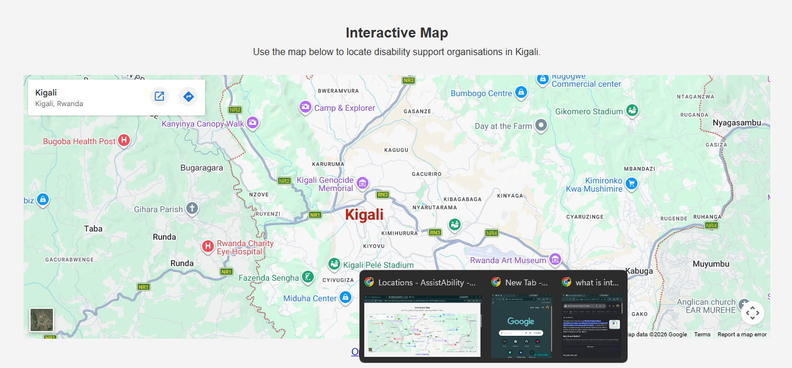
Figure 6 location page
The Locations page combines a live embedded Google Maps iframe with a static directory of verified organisations operating in Kigali, Rwanda. The map is embedded via Google's standard embed pb= parameter string and is centred on two reference points — NUDOR and the Rwanda National Union of the Deaf — giving the learner a real, interactive geographic reference rather than a generic map screenshot.
Underneath the map, a .cards grid lists six real organisations: NUDOR, the Rwanda National Union of the Deaf (RNUD), the Rwanda Union of the Blind (RUB), UPHLS, Tubiteho NGO, and the Rwanda Union of Little People (RULP). Each card carries a short description of the organisation's mandate together with its physical location within Kigali and, where available, a contact phone number. This directory was deliberately populated with organisations that genuinely exist in Rwanda rather than placeholder data, so the page can function as a real referral resource, not only a class demonstration. A closing "Services Available" list and a "Need Help?" call-to-action connect the page back to the Request Help form.

3.2.3. Visual Aids Page (pages/visual-aids.html)
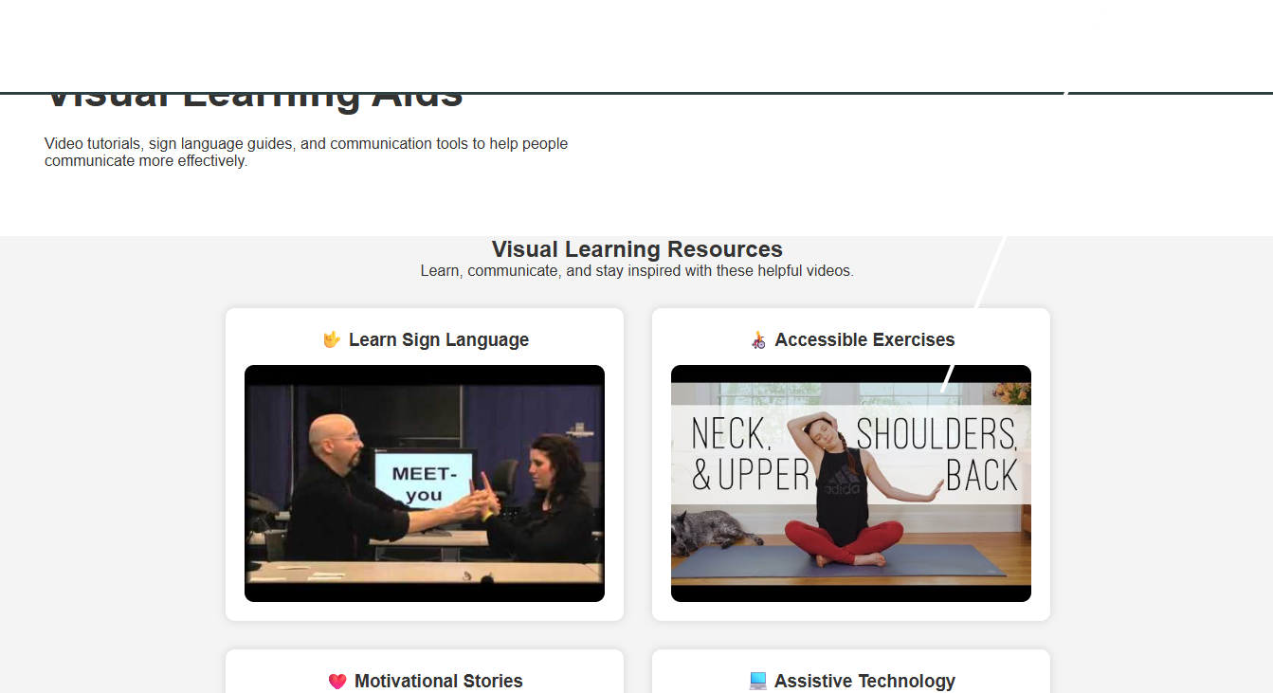
Figure 7 visual aids page
This page curates six categories of embedded YouTube content relevant to different needs: sign language instruction, accessible exercise routines, motivational stories, assistive technology demonstrations, audio storytelling, and relaxation content. Each video sits inside a .video card with its own heading and a responsive 400×250 iframe, and the whole collection is arranged with CSS flexbox (display:flex; flex-wrap:wrap) so the grid reflows cleanly from a wide desktop layout down to a narrower viewport without any JavaScript being required.
Functionally, this page demonstrates that not every "assistive" feature needs to be built from scratch — reusing existing, high-quality third-party video content (via standard oEmbed-style iframes) is itself a legitimate and pragmatic accessibility strategy for a class project with a limited timeline.

3.2.4. How to Help Page (pages/support-guide.html)
Figure 8 how to help those with disability
The How to Help page is the site's educational core. It is structured as a sequence of <section> blocks, each addressing a specific situation: general etiquette ("Respect Everyone"), supporting someone with a visual impairment, supporting someone who is Deaf or hard of hearing, supporting a wheelchair user, and supporting people with intellectual or learning disabilities. Each section uses a simple, unordered <ul> list of short, actionable guidance points (e.g. "Never push a wheelchair without permission", "Face the person while speaking") rather than long paragraphs, which keeps the content scannable and appropriate for a general audience that may be reading it for the first time under time pressure (e.g. during an emergency, which has its own dedicated section).
The page closes with three reinforcing elements: an "Accessibility Checklist" a venue or event organiser could literally tick off, a "Myths and Facts" section that directly confronts common misconceptions, and a pull-quote in a <blockquote> ("The greatest barrier is not a person's disability, but society's attitude toward disability.") that summarises the philosophy behind the whole project.

3.2.5. Request Help Page (pages/request.html)
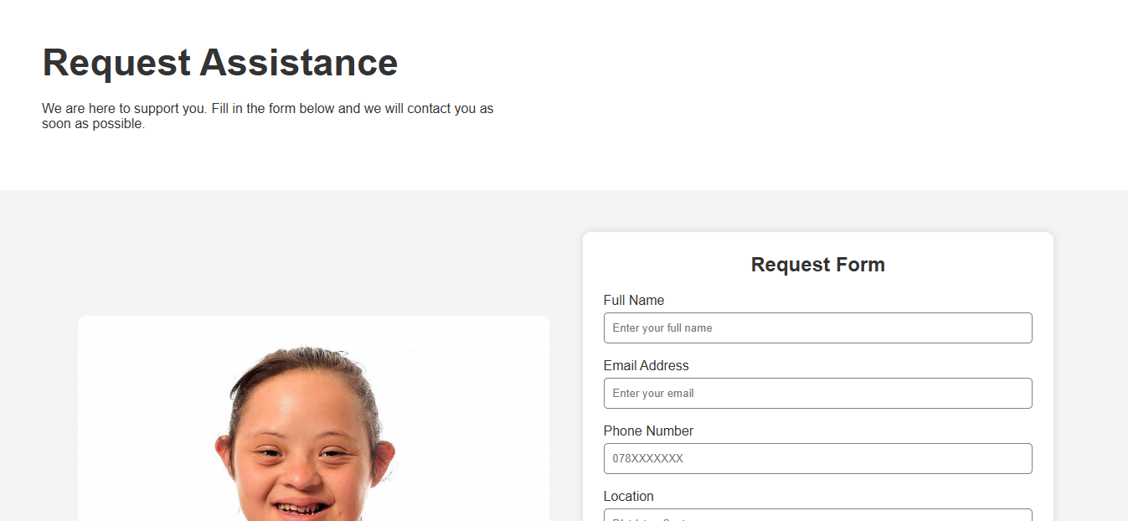
Figure 9 request for help page
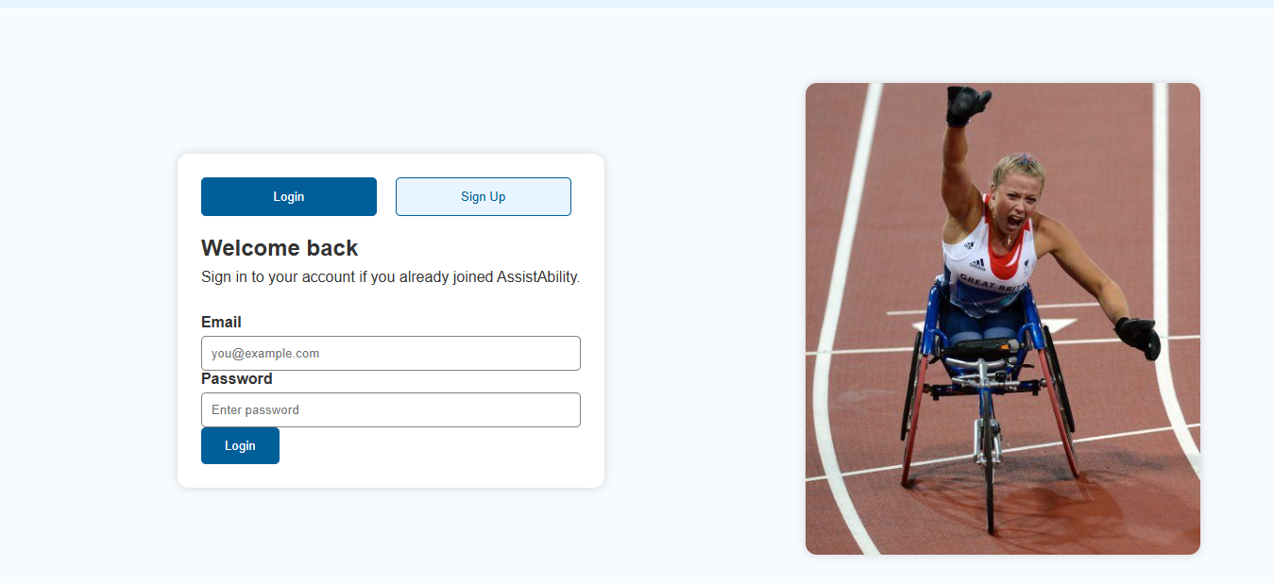
Figure 10 register as a volunteer or person with disability
This page hosts the primary conversion point of the site: the assistance-request form. It collects full name, email, phone number, district/sector location, disability type (a <select> with five options plus "Other"), urgency level (Low/Medium/High), whether the request is for the requester or someone else (radio buttons), and a free-text description of the need. The current implementation is intentionally kept as a client-side <form> with a standard submit button and no JavaScript form-handling logic yet — this was a scope decision appropriate for a front-end-focused module, leaving server-side processing as clearly identified future work (see Section 2.2.3 and the recommendations in Chapter 4).
Visually, the page pairs the form with a supporting photograph in a flex layout (.request), and the form itself is styled with consistent full-width inputs, rounded corners and a soft box-shadow (box-shadow:0 0 10px lightgray) so it reads as a single, trustworthy card rather than a collection of loose fields.

Chapter 4. Conclusion and Recommendation
Overall, the AssistAbility project successfully achieves the great majority of the objectives set out in Chapter 1. All five planned pages (home, locations, visual aids, how-to-help, and request-help) were implemented with a consistent navigation bar, footer, and visual identity. The interactive sign-language lesson works correctly end-to-end using pure JavaScript, the Locations page presents a real, verified directory of Rwandan disability organisations with a working embedded map, and the Request Help form captures all the fields a support organisation would realistically need. On a simple achievement scale, the project can be considered to have reached approximately 85–90% of its stated objectives — the remaining gap corresponds specifically to the absence of a backend to actually receive and route submissions from the Request Help form, and to the database layer, both of which were intentionally left as future work given the front-end scope of the Web Design module.

Recommendations

To the Lecturer, on Technicalities
It would be great if we were also exposed to famous frameworks that are being used nowadays but maybe in the future we will get to it, and it would be nice if we use a real website to illustrate how Api works.

To the School, on Time Constraints
Given that a project of this nature genuinely benefits from real user feedback (for example, from an actual visually impaired user testing the sign-language lesson, or a wheelchair user reviewing the How to Help checklist), a slightly longer assessment window that allows for at least one round of informal user testing would materially improve the realism and impact of similar projects.

To the Partners (Targeted Organisations)
Organisations such as NUDOR, RNUD, and RUB, currently listed as static directory entries, are encouraged to consider a lightweight, low-cost integration (even a shared spreadsheet-backed API) that would let a future version of this site route Request Help submissions to the correct organisation automatically, based on disability type and district.

To the User, on Training
Because the sign-language lesson and the How to Help guide are both entirely self-explanatory and require no login or account, no specific training is required for end users beyond normal web-browsing familiarity; a short in-person or video walkthrough could nonetheless help first-time visitors discover the Request Help entry point more quickly.

To the Beneficiaries, on the New Tool
Persons with disabilities and their families are encouraged to treat the current version of AssistAbility as an informational and educational resource — particularly the Locations directory and How to Help guide — while being aware that the Request Help form does not yet route to a live response team, pending the backend work recommended above.

Appendix.
https://github.com/paulkwizera/assistability

